CS 255 System Design Document Template

UML Diagrams

UML Use Case Diagram
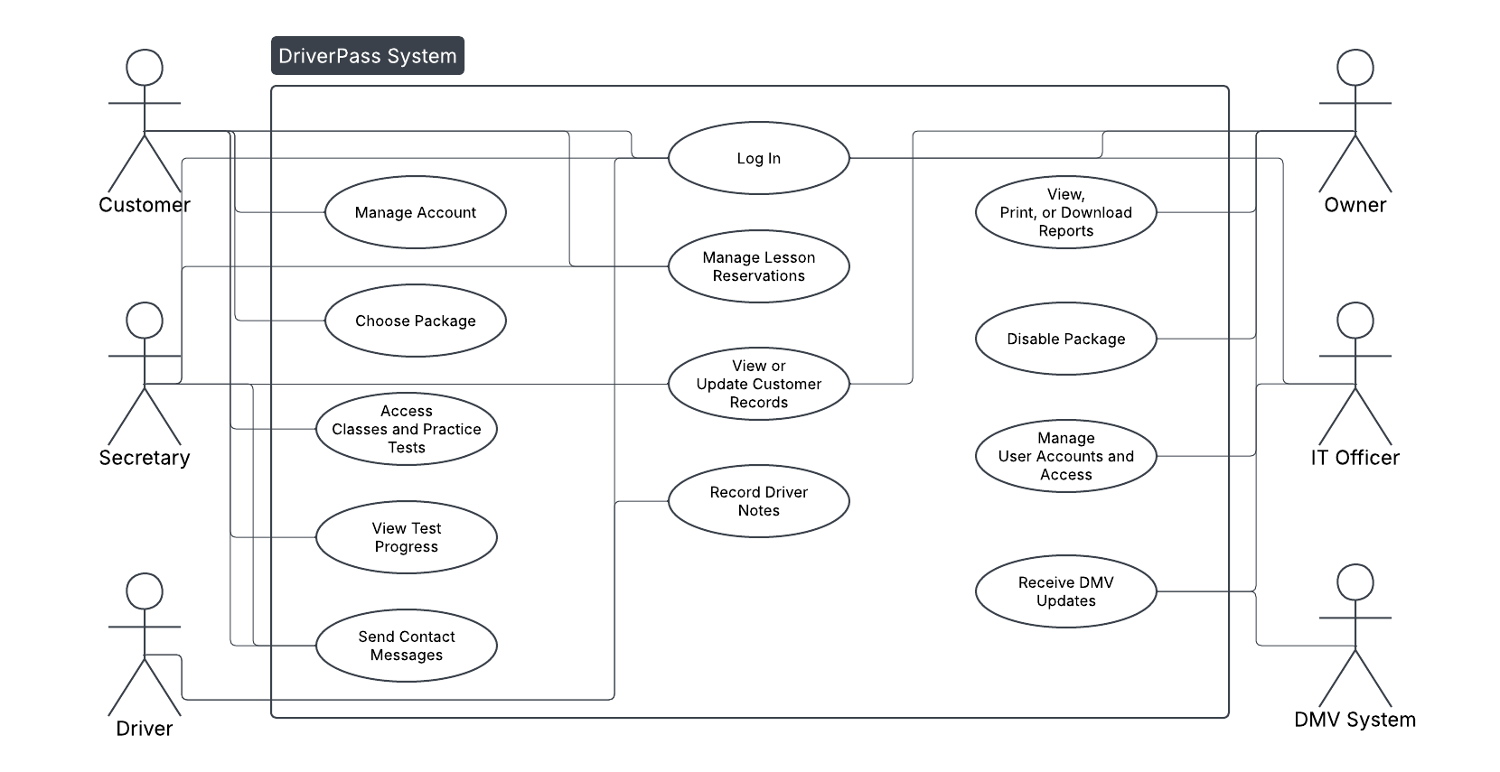

UML Activity Diagrams
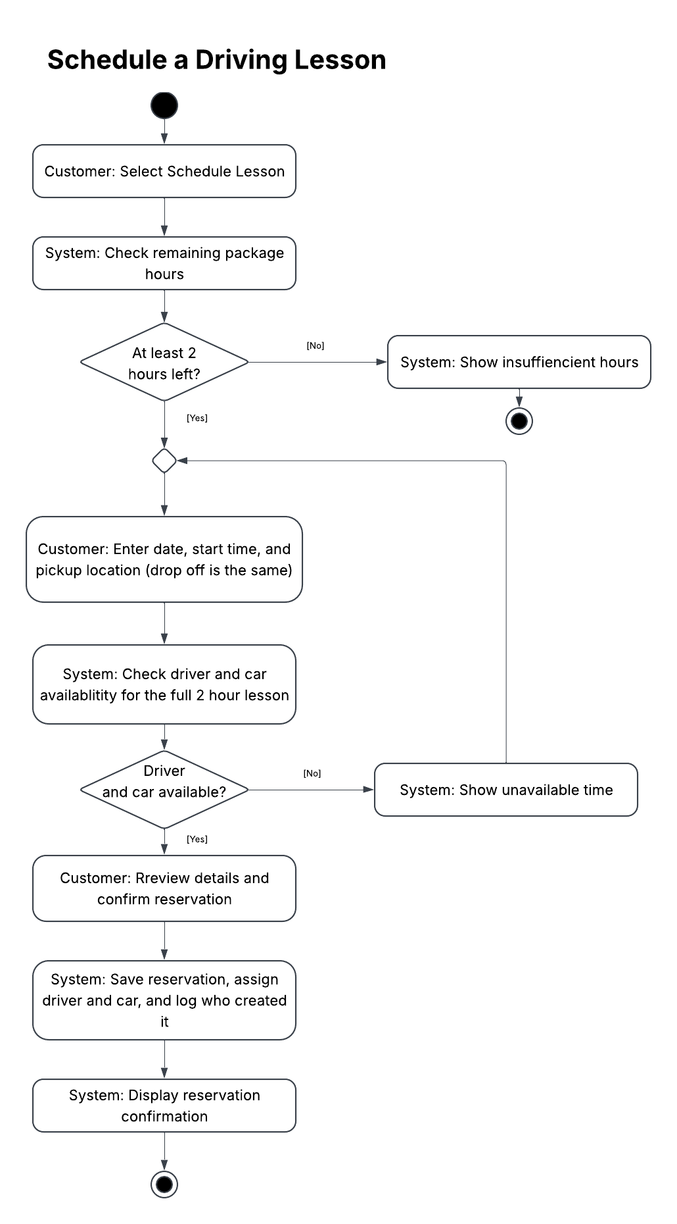
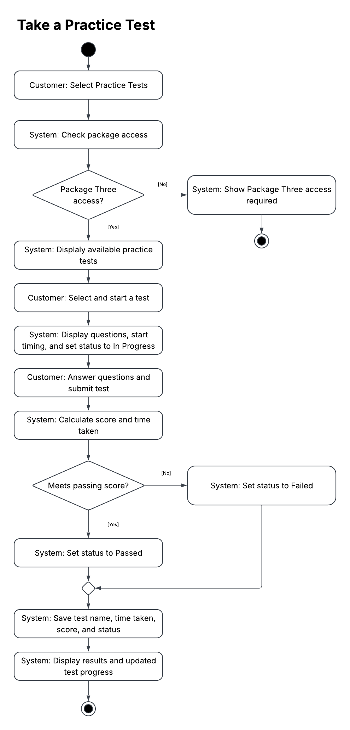

UML Sequence Diagram
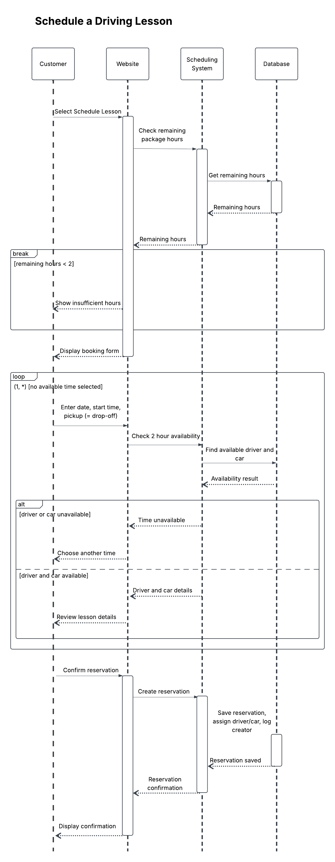
UML Class Diagram
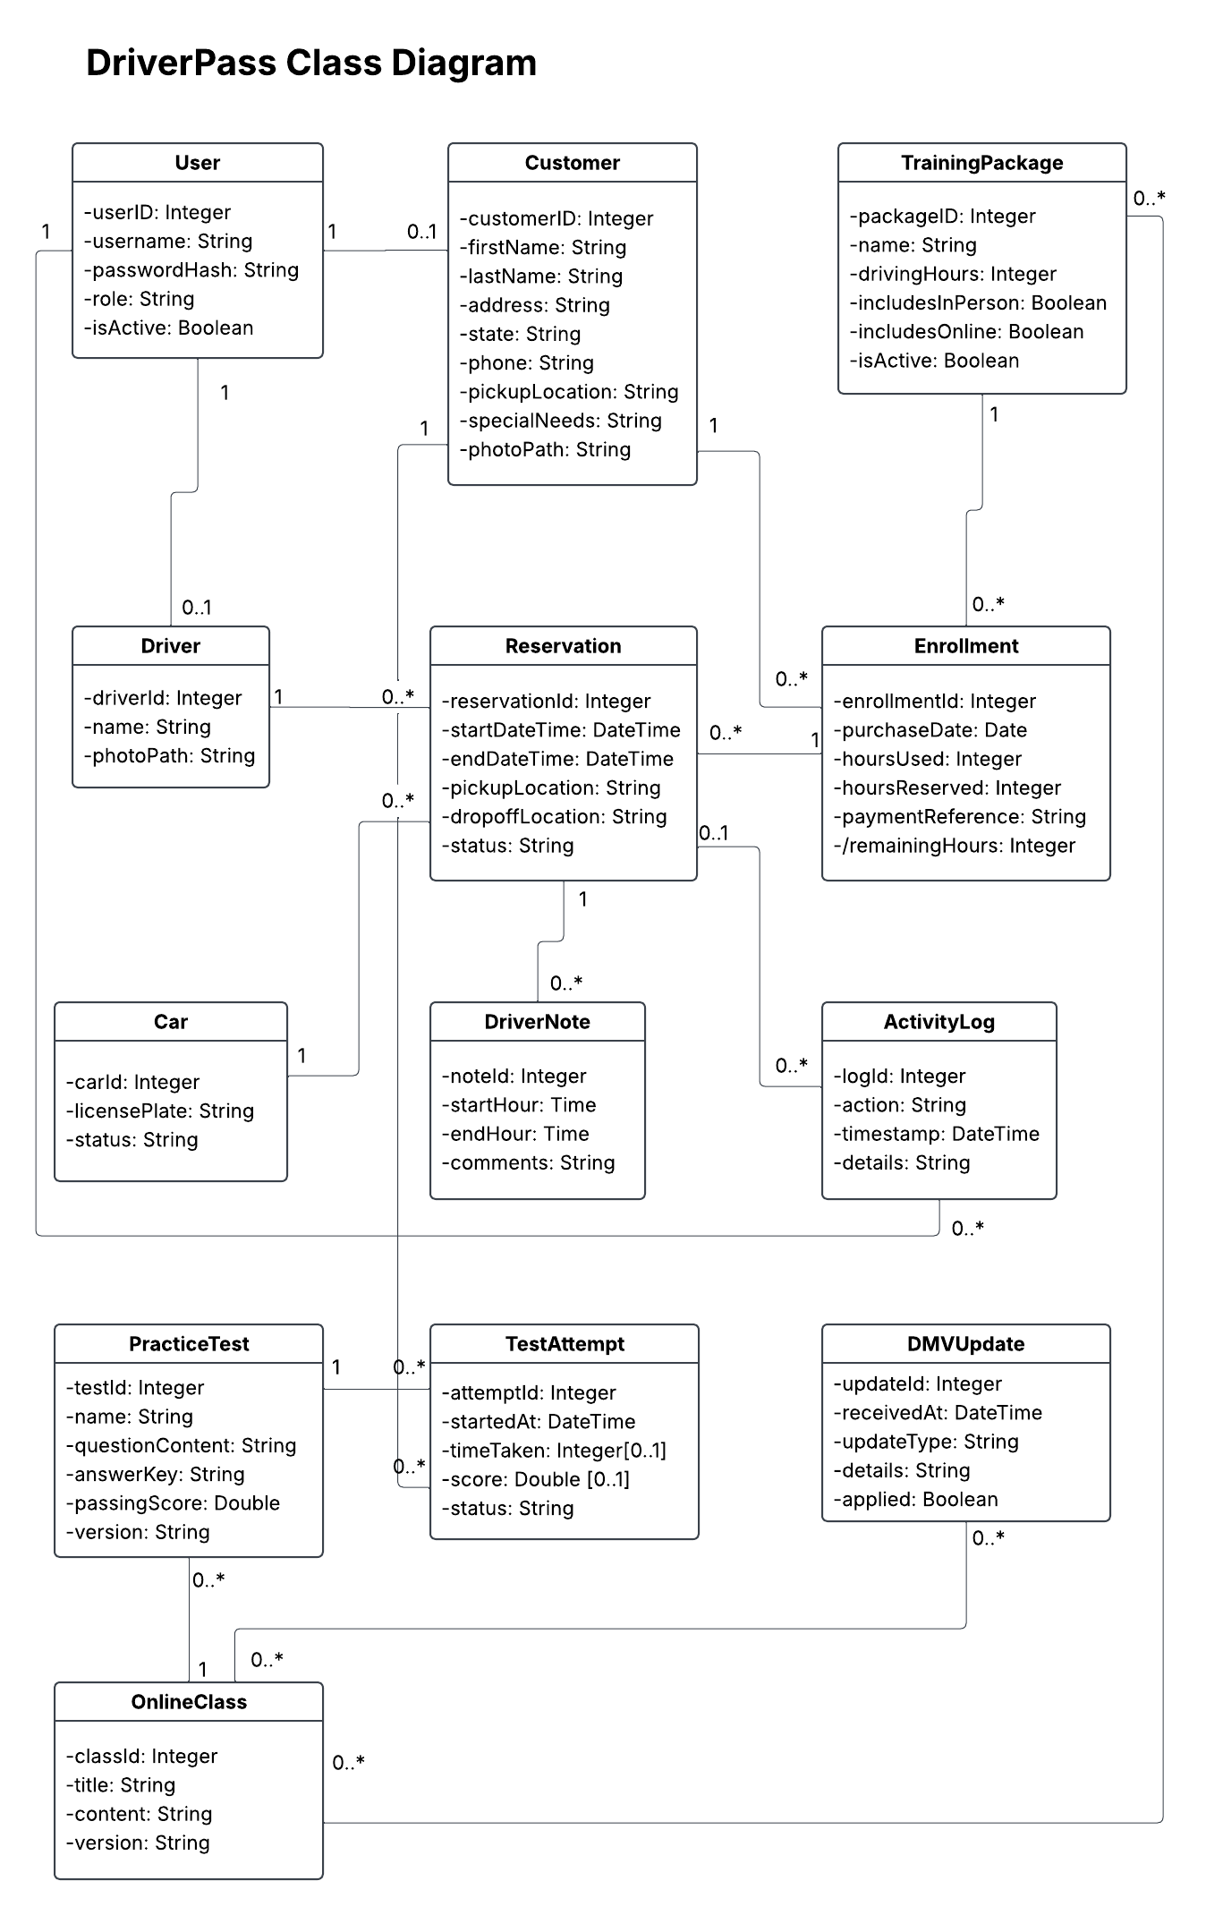

Technical Requirements
Hardware and access: Customers and staff will need an internet-connected computer, tablet, or smartphone with a web browser. DriverPass will need a printer for reports and Excel or compatible software for downloaded files. Reports can be viewed offline, but live changes require an internet connection.
Software and database: The proposed system will use a Java back end and a responsive interface built with HTML, CSS, and JavaScript. A relational database will store the records shown in the class diagram, including accounts, packages, enrollments, reservations, drivers, cars, test attempts, and activity logs. Unique identifiers will connect related records. Reports must support printing and Excel-compatible downloads.
Scheduling and tests: The system must verify available package hours and driver and car availability for each two-hour lesson. Booking checks and updates must prevent conflicting reservations, even when users book at the same time. Cancellations must release reserved hours and availability. Online classes and practice tests must be limited to Package Three customers. Test records must include the test name, time taken, score, and status.
Security: The system must use HTTPS, securely hashed passwords, and permissions based on user roles. It must support secure password resets, account blocking, and protection against repeated failed login attempts. Activity logs must identify who created, canceled, or modified reservations. The proposed payment service will process card information securely, while DriverPass stores only a payment reference.
Infrastructure: Cloud hosting must support the Java application, database, and file storage. It must include automated backups, tested recovery procedures, monitoring, and restricted access. An agreed DMV connection or update process must provide current information and update notifications. The specific connection must be confirmed before implementation.
Development tools: The proposed tools include Lucidchart for diagrams, Eclipse for Java development, Git for version control, and JUnit for testing scheduling, scoring, and access controls.

